PYTHON PROJECT
Title: Student Record Management System using Python Name: Sivajothi M
Register No: 411625149046 Department: B.E CSE (Cybersecurity) Batch No: 04
Subject: Fundamentals of Programming

AIM
To design and develop a Student Record Management System using Python that demonstrates the fundamental concepts of programming such as variables, data types, functions, lists,
dictionaries, operators, and decision-making.

OBJECTIVE
- To understand basic programming concepts
- To implement real-world data management using Python
- To use lists and dictionaries for storing student data
- To perform operations like add, display, search, and delete records
- To apply conditional statements and functions
- To create a menu-driven interactive program

PROCEDURE (Detailed)
- Open Python IDLE or any editor and create a new file named student_system.py.
- Initialize an empty list to store student records.
- Define a function add_student() to:
  - Accept student name, roll number, and marks
  - Store the data as a dictionary
  - Append it to the list

- Define a function display_students() to:
  - Show all student records using iteration
- Define a function search_student() to:
  - Accept roll number
  - Search and display matching student
- Define a function delete_student() to:
  - Remove a student record based on roll number
- Define a function calculate_grade():
  - Assign grade based on marks using conditions
- Use a menu system to allow user to choose operations:
  - Add Student
  - Display Students
  - Search Student
  - Delete Student
  - Exit
- Use a loop to continuously run the program until user exits.
- Validate user input to avoid errors.
- Display appropriate messages for each operation.
- Test the program with multiple cases to ensure correctness.

PYTHON CODE
students = []

def calculate_grade(marks): if marks >= 90:
return "A"
elif marks >= 75: return "B"

elif marks >= 50: return "C"
else:
return "Fail"

def add_student():
name = input("Enter Name: ") roll = input("Enter Roll No: ")
marks = int(input("Enter Marks: ")) grade = calculate_grade(marks)
student = {
"name": name,
"roll": roll,
"marks": marks, "grade": grade
}

students.append(student)
print("⬛ Student Added Successfully!")

def display_students(): if len(students) == 0:
print("No records found!") else:
print("\nStudent Records:") for s in students:
print(s)

def search_student():
roll = input("Enter Roll No to search: ") for s in students:
if s["roll"] == roll: print("Found:", s)

return
print("Student not found!")

def delete_student():
roll = input("Enter Roll No to delete: ") for s in students:
if s["roll"] == roll: students.remove(s)
print("Deleted Successfully!") return
print("Student not found!")

def main(): while True:
print("\n--- Student Management System ---") print("1. Add Student")
print("2. Display Students") print("3. Search Student") print("4. Delete Student") print("5. Exit")
choice = int(input("Enter choice: ")) if choice == 1:
add_student()
elif choice == 2: display_students()
elif choice == 3:
search_student() elif choice == 4:
delete_student() elif choice == 5:
print("Exiting program...") break
else:
print("Invalid choice!")

main()

OUTPUT
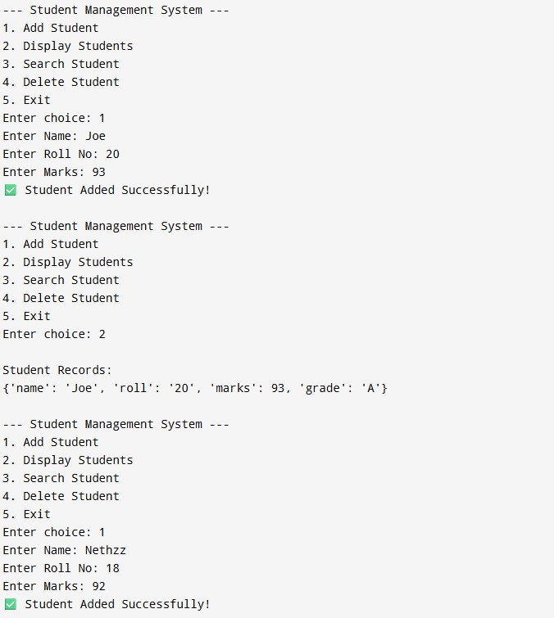

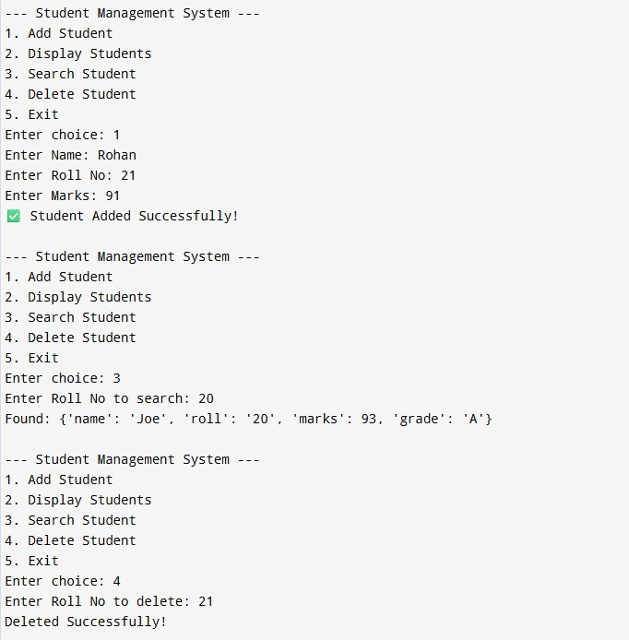
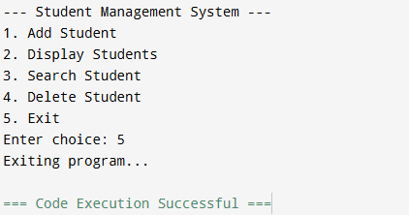

RESULT
The Student Record Management System was successfully implemented using Python. The program demonstrated fundamental programming concepts such as functions, lists,
dictionaries, and decision-making.

CONCLUSION
Thus, the project was successfully developed using Python. It helped in understanding real- world applications of programming fundamentals and improved problem-solving and coding skills.

